Angular Notes

CS 4910, Software Engineering (Copus, Summer, 2017)  
v 0.1 (5/26/2017)

# Separate .js and map files from .ts files

This change makes for a much cleaner structure. Without it, the src directory becomes quite cluttered with transpiled files and such. With it, only your TypeScript (.ts) files are present—much easier to navigate!

1. Create a new directory at the same level as src. Mine is called ‘dist’:

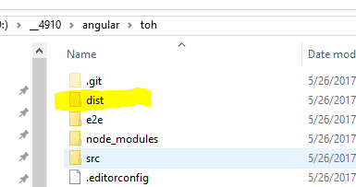

1. Tell the compiler where to put the .js files by adding a line to tsconfig.json:

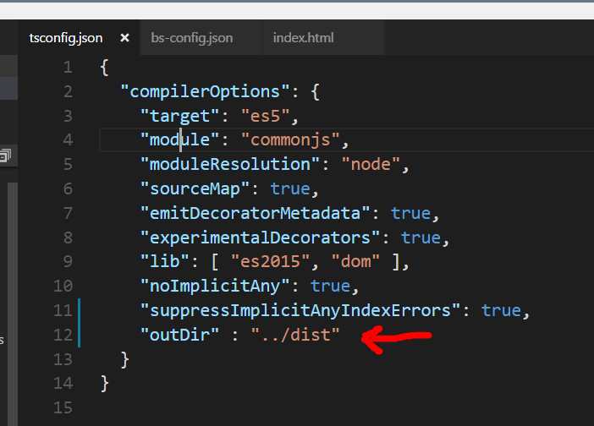

1. Turn the baseDir property of the server object to an array in bs-config.json, and add your directory to the array (along with “src”):

